


CL1002  Programming Fundamentals | Lab 02  Introduction to User Input and Output, Variables, Operators and Problem-Solving using Decision and Iterative Structures using Scratch Programming

National University of Computer and Emerging Sciences
Fall 2025

Aims and Objectives

The aim of this lab is to equip students with scratch programming platform and apply fundamental programming concepts to demonstrate their skills. The objectives of this lab are as follows.

1. Teach students how to receive input from users and display output using Scratch.
2. Teach students the concept of variables in Scratch and how to create, assign and use them within programs.
3. Guide students in using Scratch's Operator blocks to perform arithmetic operations such as addition, subtraction, multiplication, and division.
4. Introduce students to the relational (comparison) operator blocks in Scratch and show how they enable decision-making by comparing values
5. Introduce students to the decision and iterative blocks in scratch programming to determine and repeat some series of statements respectively.

Introduction
In this lab we will be covering the following topics
- User Input and Output.
- Create and Assign Variables.
- Arithmetic Operators
- Relational Operators
- Introduction to Decision and Iterative Structures

Objective: 1 User Input and Output
•Definition: User input is a mechanism for receiving information from the user like asking a question and output is a mechanism of communicating information back to the user like displaying messages or sprites speaking
•Importance: It’s fundamental to know how exactly you are going to communicate to and from the sprites.

Example
Here we have a scenario where a sprite named as abby is walking on the track and asking what’s your name and then we provide a name in the user input after that abby says Hello, and whatever the name you have provided.
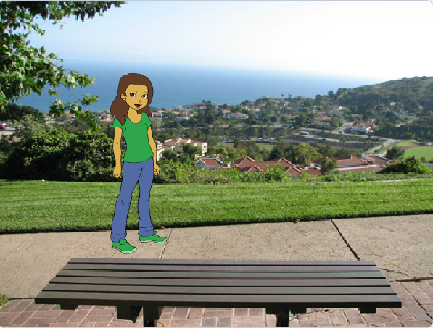
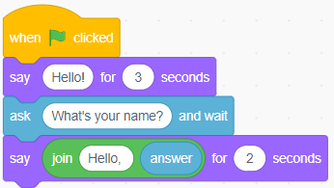

Figure: SEQ Figure \* ARABIC 1 User Input and Output
Some more problems to solve
Problem#01
Create a sprite that greets you by asking your name and student id.

Objective: 2 Create and Assign Variables
Variables are containers that hold values which can change over time. In Scratch, variables can store data such as numbers, text (strings), and Boolean values (True/False).
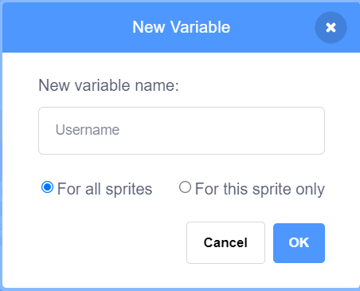
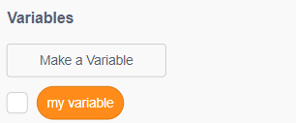
Students can create a variable using the “Make a variable” button in the Variables category. Each variable must have a name (e.g., “score”, “Username”) and a scope (for all sprites or just one sprite).

Figure: SEQ Figure \* ARABIC 2(a) Creating Variable Username

Example
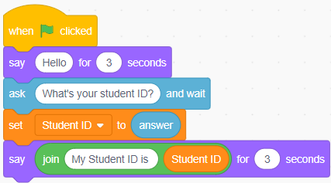
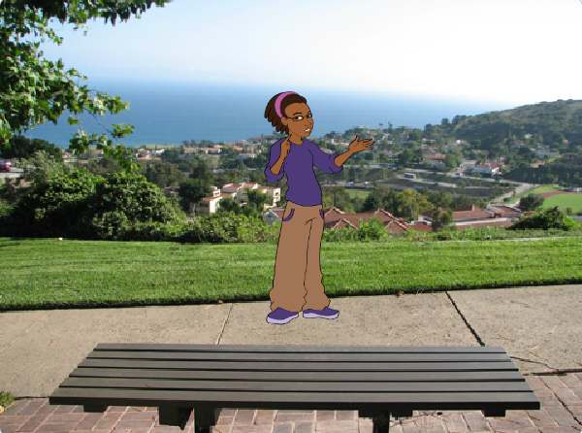
Here we have a scenario where a sprite named as avery is walking on the track and asking what’s your student ID and then we provided the student ID and stored it into variable named as student ID and displayed the message with student ID.

Figure: 2(b) Creating Variable StudentID

Some more problems to solve
Problem#02
Imagine you are designing student details record system. Create a scratch program that collects information from the user about a student and calculates the obtained marks and percentage based on the marks entered. The program should include the following steps:
- Ask the user to enter the student’s ID, student’s Name, marks for Subject 1, marks for Subject 2, and marks for Subject 3.
- Calculate the obtained marks by adding the marks for all three subjects.
- Calculate the percentage obtained by dividing the obtained marks by the maximum possible marks (assuming each subject has a maximum of 100 marks) and multiplying by 100.
- Display the student’s details (ID and Name), the obtained marks, and the calculated percentage.

Objective: 3 Arithmetic Operators
Operator Blocks: Scratch includes a suite of operator blocks (found under the Operators category) that handle arithmetic operations:
- Addition: +
- Subtraction: −
- Multiplication: ×
- Division: ÷
These blocks accept numerical inputs and return the result of the calculation

Example
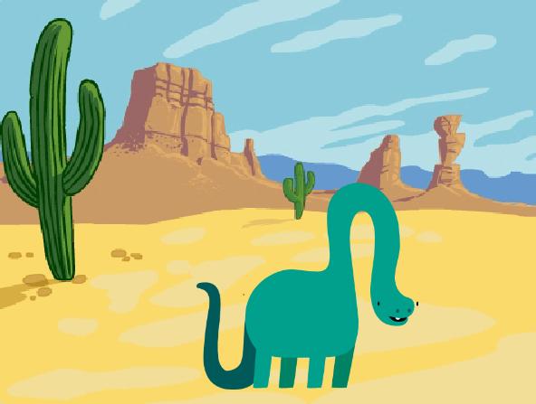
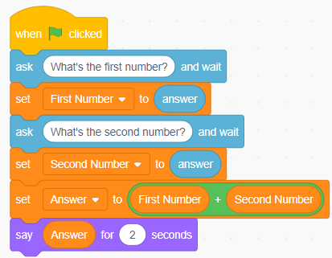
In the following scratch programming example, we are taking two user inputs what is the first number and what is the second number and storing the numbers in first number and second number variable respectively and besides that creating an answer which will store the result of the addition operation and will display the result of the calculation.

Figure: SEQ Figure \* ARABIC 3 Addition Calculation with User Input
Some more problems to solve
Problem#03
Create a scratch program that calculates the area of a rectangle. Ask the user for the length and width, then display the calculated area?
Problem#04
Create a scratch program that converts Celsius to Fahrenheit. Ask the user for a temperature in Celsius and display its equivalent in Fahrenheit using the formula: Fahrenheit = (Celsius * 9/5) + 32.

Objective: 4 Relational Operators
Relational Operators in Scratch are found in the Operators category and include:
- = (equal to)
- < (less than)
- > (greater than)
- ≤ (less than or equal to)
- ≥ (greater than or equal to)
- ≠ (not equal to)
These operators return Boolean results: either true or false.

Example
In the following example we are asking the dinosaur it’s age and dinosaur provides his age and then using greater than relational operator we are determining whether the dinosaur’s age is greater than 50 or not.

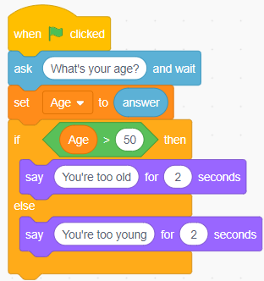

Figure: SEQ Figure \* ARABIC 4 Determining Age using Relational Operator

Some more problems to solve
Problem#05
Create a scratch program to store a predefined password in a variable. Prompt the user, then check using relational operators whether the access is “granted” or “denied”.

Objective: 5 Decision and Iterative Structure
Decision Structure: A statement or a set of statements that is executed when a particular condition is “True” and ignored when the condition is “False”.
In scratch, we use the following control diagrams for decision structure.
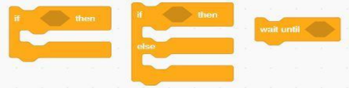
Figure: 5(a) If, If-else and wait until block

Example
Given a number as an input by a user, check if the number is a negative number or a positive number.
Flowchart of Decision  Structure | Scratch Diagram | Output
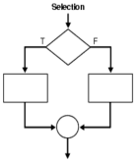 | 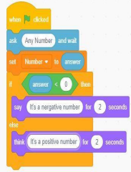 | 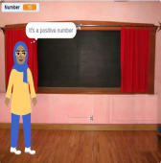
Figure: 5(b) Positive and Negative Number

Iterative Structure: The statements that cause a set of statements to be executed repeatedly either for a specific number of times or until some condition is satisfied are known as iteration statements.

In scratch, we use the following control diagrams for iterative structures:

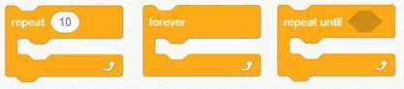
Figure: 5(c) Repeat, Forever and Repeat Until

Example
Set a counter to 1 and repeat until the given condition is satisfied. In this case, the given condition is counter=10.

Flowchart of Iterative Structure | Scratch Diagram | Output
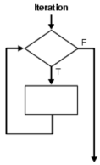 | 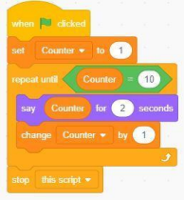 | 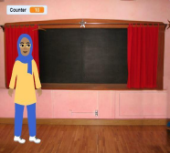
Figure: 5(d) Counter Variable

Example
Find the sum of first 10 Natural Numbers using repetitive block.
Scratch Diagram | Output
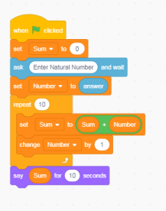 | 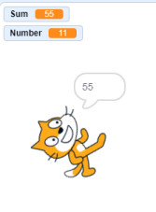
Figure: 5(e) Sum of Natural Numbers

Example
Draw a pentagon with the help of repeat and pen diagrams. Repeat the shape for five times.
Scratch Diagram | Output
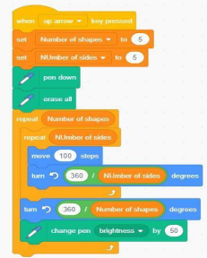 | 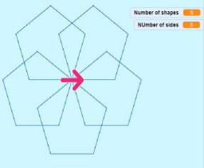
Figure: 5(f) Pentagon

Task 1: Personalized Greeting
Create a program where a sprite asks the user for their name and then gives a personalized greeting, such as "Hello, [Name]! Welcome to Scratch!".

Task 2: Simple Calculator
Create a program that asks the user for two numbers. Store them in variables. Then, calculate and display the sum, difference, product, and quotient of the two numbers.

Task 3: Student Grade Calculator
Expand on Problem#02 from the lab. After calculating the total marks and percentage, use decision blocks to also assign and display a grade based on the percentage (e.g., A for >= 90, B for >= 80, etc.).

Task 4: Temperature Converter with Feedback
Create a program that converts a user-input temperature from Celsius to Fahrenheit. Use a relational operator to check if the converted Fahrenheit temperature is above 100. If it is, the sprite should say "It's hot!"; otherwise, it should say "It's cool."

Task 5: Password Checker
Create a program that stores a correct password in a variable (e.g., "NUCES"). Ask the user to enter a password. Use relational operators to check if the entered password matches the stored one. The sprite should say "Access Granted" if it matches and "Access Denied" if it does not.

Task 6: Countdown Timer
Create a program that asks the user for a starting number. Use a `repeat until` loop to make a sprite count down from that number to 1, saying each number for one second. When it reaches 0, the sprite should say "Blast Off!".

Task 7: Even/Odd Number Identifier
Create a program that asks the user for a number. Use an operator (hint: the `mod` block found in Operators) to determine if the number is even or odd. The sprite should then report the result (e.g., "Your number is even").

Task 8: Sum of a User-Defined Range
Ask the user for a starting number and an ending number. Use a loop to calculate the sum of all whole numbers from the start to the end (inclusive). Display the final sum.

Task 9: Interactive Shape Drawer
Create a program that asks the user how many sides they want a shape to have (e.g., 3 for triangle, 4 for square). Use a `repeat` loop with that value to draw the corresponding shape using the pen tools.

Task 10: Number Guessing Game
Create a game where the program randomly chooses a number between 1 and 10 (use the `pick random` block from Operators) and stores it in a variable. Ask the user to guess the number. Use decision structures to tell the user if their guess is too high, too low, or correct. Use a loop to let the user keep guessing until they get it right.

